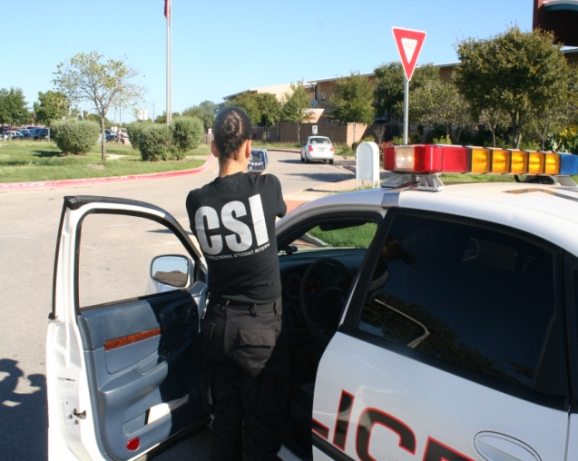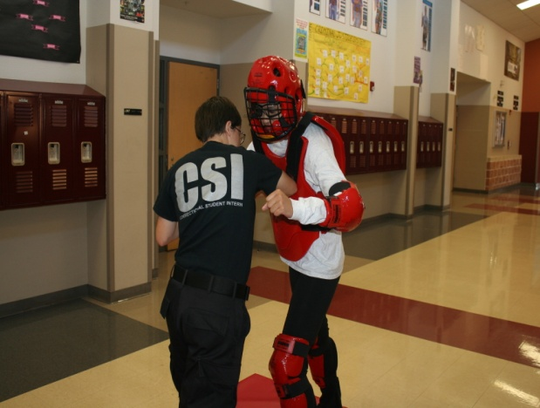

Mr. David Lopez

Criminal Justice Instructor

Akins High School

Before earning my teacher certification, I was in the US Navy (Desert Storm Veteran) stationed on the USS Ranger CV-61. I was also a full time peace officer that held various ranks from School Resource Officer, Detective, and to Sergeant. I was fortunate to be offered a position by **Adan Ballesteros, Constable Travis County Pct. 2,** as a Part-Time Investigator/Public Relations Officer. As a teacher I have received AISD’s 2005-2006 Teacher of Promise Award, KEYE’s Silver Apple Award, and KXAN’s Teacher of the Week. I have been a public servant my entire adult life, but my most rewarding experience has been working in the educational field. I look forward to the challenges ahead as I continue to help my students achieve their goals.





Mr. David Lopez Criminal Justice Instructor

10701 South 1st Street

Austin, TX 78748

www.akinseagles.org/criminal-justice-program/

E: dlopez3@austinisd.org

P: 512-841-9763

F: 512-841-9796

W. Charles Akins High School

AKINS CRIMINAL JUSTICE PROGRAM

Corrections Services Internship

Applicants for Corrections Officer must complete the following course within 3:30 seconds:

* 200-yard run
* Jump over six hurdles ranging from 6” to 4’ (You may use your hands on the last 3 hurdles).
* Walk across a balance beam
* Drag a 150-lb dummy
* Run through a serpentine wall
* Run three flights of stairs
* Run through a sandpit
* Run through a series of heavy bags
* Crawl under a 3’ obstacle
* Climb over a 4’ chain link fence
* NOTE: Applicants will get 3 attempts at each obstacle. Failure to clear the obstacle within 3 attempts will disqualify the applicant from the job specific testing. If it appears that an applicant is injured, they will be stopped and not be allowed to continue.

Year-Long Internship

The students will prepare for certification required for employment as a Security Coordinator with Travis County Sheriff’s Office. The student will learn the roles and responsibilities as well as relevant rules, regulations, and laws. Students will learn defensive tactics, restraint techniques, analyze rehabilitation practices as well as institutional alternatives.

Pay – Benefits

* Competitive salary starting at $38,919.50 per year for a cadet and $52,301.81 per year for a deputy
* 15% Shift Differential for medical staff working B or C Shift (3-11pm, 11pm-7am) and 5% Shift Differential for non-officer positions
* Supplemental pay for advanced licensure, bilingual and Field Training Officer on sworn positions
* Approximately 11 paid holidays per year
* 12 paid vacation days per year; vacation days increase with years of service
* 3 personal holidays per year
* Retirement plan
* Deferred Compensation Plan available
* Paid medical for employees
* Life insurance
* Tuition reimbursement
* Paid training

Paid uniforms for applicable positions

**Akins High School is proud to offer eligible students the TLPSCS certification program! Established in North Texas, The *Texas Law, Public Safety, Correction and Security* program is highly competitive and growing at a phenomenal rate. The course is designed to give students an insight into the correctional field with a challenging curriculum, as well as hands-on experience with actual Deputy Sheriffs working in Texas jails. This elite program takes a select few students (10-14) who have met the requirements only offered at Akins in the ABL²E academy. Akins’ partnership with the Travis County Sheriff’s Office has been instrumental in the success of the students participating in this program. After the yearlong course is completed students, are certified and eligible to work in Texas jails. During the program students also receive OSHA and CPR certifications**.

Job Specific Test – Corrections Officer

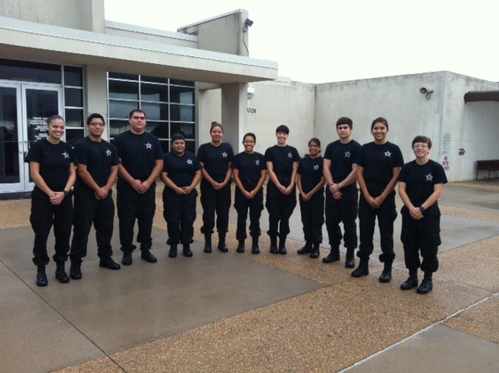

PLACE PHOTO HERE,

OTHERWISE DELETE BOX

Corrections Services Internship

• Only Seniors are eligible.

• Must have parent approval.

• Must be able to pass a criminal background investigation.

• Satisfactory discipline and attendance.

• Successful interview by a committee.

How do I qualify?